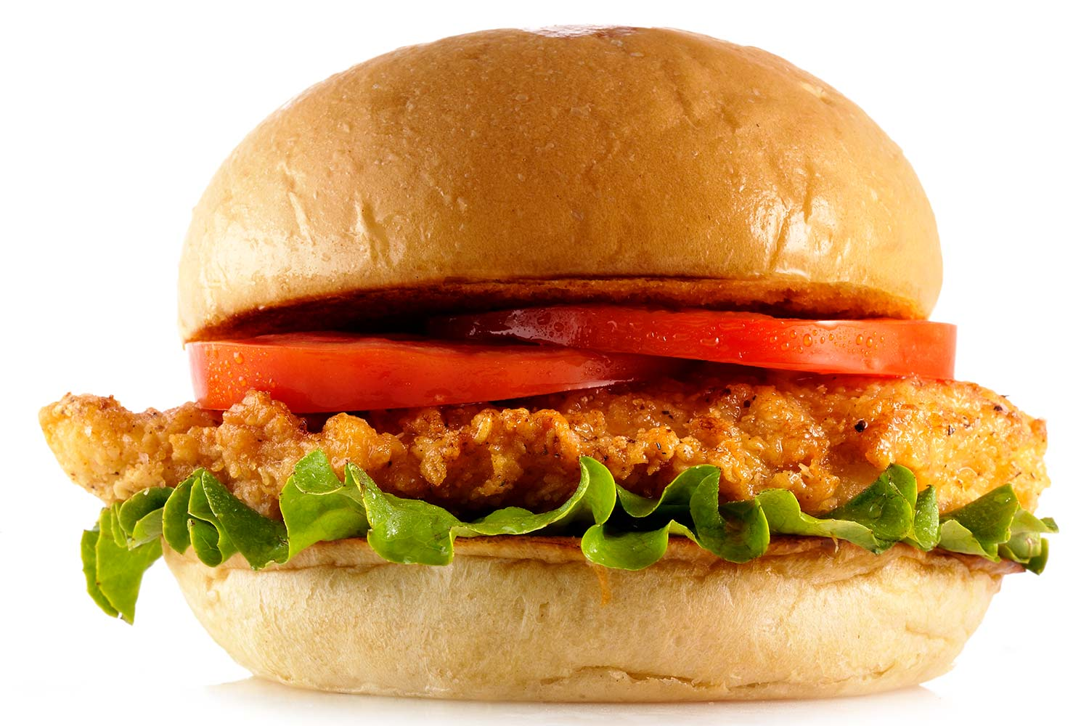

**Served With**

**Waffle Fries**

**6.99**

**$**

**Chicken Sandwich**

**Thursday Special**